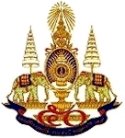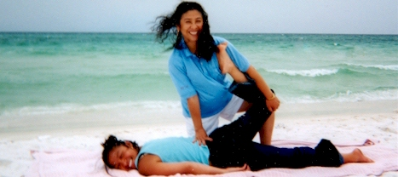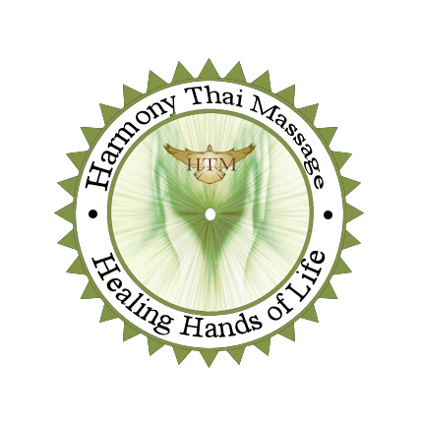
Certifies
Cristina Isget
Thai Massage on Table
Has completed
12 Hours
JANUARY 29, 2016
_____________________________
Instructor: Souri Sisavath CE0231
NCBTMB Approved Provider # 450345-07

